# Data stream processing – TP3

1. Create a simple web application (HTML page) or choose an existing web application source from the internet and write a Dockerfile to build a custom Docker image for your web application.

First, we need to create a html source code :

Then we need a python file the render and run the app with flask :

Before building the docker, we create a dockerfile, which will be the executed routine when we build our image.

Then we can build our image :

1. Run a container using the custom Docker image you built

1. Access the web application running inside the container from your host machine's web browser.

1. Use Docker volumes to mount local directories containing application files (HTML pages) into the container and modify the web application and check whether the changes are reflected on the application.

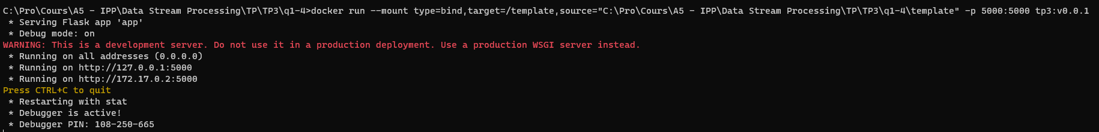

Now, to test if it works, I’ll change the image in my “index.html” without re-building the container. The image should change inline on my running instance :

It worked, our volume allows us to communicate and modify our container in a controlled manner.

1. Deploy a Mysql Database Container and modify your web application to use the mysql service running on the other container.

First, we need to update our dockerfile and add a mysql python library (SQLalchemy here)

We’ll change our build method and use a docker-compose method using a .yaml file as follows:

